iPerf Automation Quick Start Guide.

Requirements

- iPerf Tool ( Version 2 )
- One Router (Set to channel depending on the interference requirement).
- Two test systems. (Laptops)
- Testing Device (DUT with proper setup)

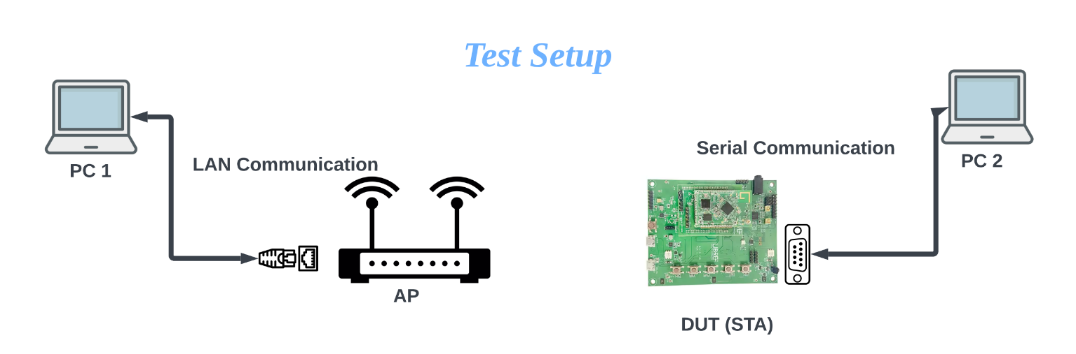
Pre-Conditions

Before proceeding with the test, ensure the following conditions are met:
- PC1 is connected to the AP (Access Point) through LAN.
- PC2 is connected to the same AP through Wi-Fi.
- DUT is connected to PC2 through a serial cable.
- Ensure there are no network interferences during the test.
- DUT should be factory reset before starting the test.
- Ensure that DUT is connected to Wi-Fi antennas.

Interactive User Input

- On PC1, navigate to the directory where the primary script and Iperf tool are saved and run it using the command terminal or any text editor.

- After running the script, it will display the host IP address.

- On PC2, navigate to the directory where the secondary script is saved and run it using the command terminal or any text editor.

- The script on PC2 will prompt you to select the COM port to which the DUT is connected through the serial cable.

- Choose the device type by entering either 0 (for LS10) or 1 (for LS11).

- Enter the distance between the AP and the DUT. It's recommended to start with a shorter distance (e.g., 1 meter).

- Select the test bandwidth range by entering 1, 2, or 3:

1: 5M - 25M
2: 10M - 50M
3: 20M - 100M

- Choose the test type by entering 1, 2, or 3:

1: RX Test
2: TX Test
3: Full Test (RX Test & TX Test)

- Enter the 2.4GHz SSID and Password.

- Enter the 5GHz SSID and Password. Note that if the 2.4GHz credentials are incorrect, the test will fail at the beginning, but if the 5GHz credentials are wrong, it will fail during execution.

- Enter the host IP address displayed on PC1. The scripts are now ready to start.

Execution Sequence

- When you enter the host IP address on PC2, the secondary script will start connecting to PC1 through sockets.

- All the test details entered on PC2 will be sent to PC1 to save in the results.

- PC2 shares the 2.4GHz Wi-Fi credentials with DUT and attempts to connect.

- Once DUT is successfully configured on the network, PC2 fetches the device IP address and current network RSSI values approximately 5 times, calculates the average, and shares this data with PC1 for further testing.

- Depending on the user input test type, PC1 sends commands to PC2, which then activates the test on the DUT.

- Once the test starts, PC2 calculates the average for the first 60 seconds for 3 iterations and sends the data to PC1.

- If PC2 cannot calculate an average for 3 iterations, it notifies PC1. PC1 then continues executing more iterations until PC2 obtains 3 iterations of output.

- Once PC2 has 3 iteration data, it calculates the average and compares it to the PASS criteria. If the data meets the criteria, PC2 shares the data with PC1 to continue the test. If not, it stops the current test, attempts to connect to 5GHz, and performs the same test.

- All test data is collected and stored on the primary side in an Excel file with the specified format.

- After script execution is complete, secondary script logs and device logs are sent to the primary and stored in a log’s directory along with the primary script's logs.

.

